DOS PM
Version 1.0

Resource Kit

Overview
DOS PM is a 32-bit kernel replacement for the FreeDOS operating system. It uses linear memory addresses, and operates in protected mode on the Intel x86 architecture.

DOS PM Structure
The following diagram shows how the various layers of DOS PM are connected:
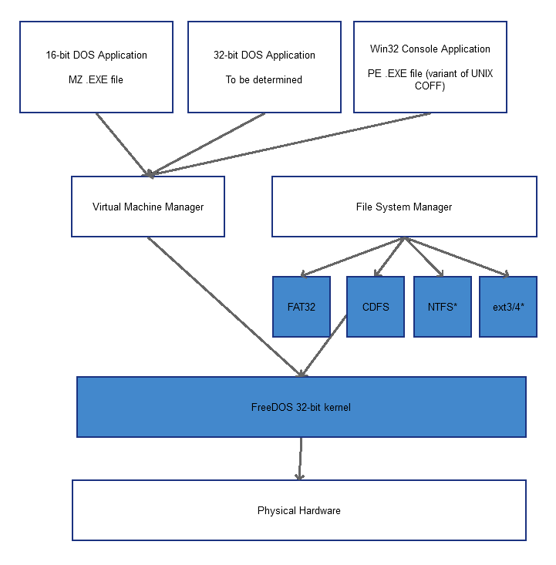

Hardware Layer
This is the core of the computer, your basic mouse, keyboard, hard drives, and such. Without an operating system, these parts can do nothing for you. Since DOS PM implements a multi-tasking kernel, it must isolate applications from the hardware and virtualize the hardware to prevent system crashes. This virtualization allows for multiple requests to be made to the hardware, which is then prioritized and serialized by the next layer in DOS PM...

The I/O Supervisor
This controls all input and output of the operating system. This is a highly critical portion of code that prioritizes and fields requests from different processes for hardware device input/output.

Kernel
DOS PM's kernel consists of 3 components. The kernel portion's primary job is to schedule processes for running, this kernel has been tweaked and optimized to run very fast using hand-tuned assembly code to optimize code and data usage.
The File System portion of the kernel handles all block device requests (whether local or remote) using a unified set of procedures and data structures. This allows seamless integration of multiple file systems through an installable file system manager. All instances of file activity are invisible to the caller as this portion of the kernel routes information to the correct device.
The final portion of the kernel is the memory manager. As the most important part of DOS PM's core components, the memory manager allocates memory on a demand basis. It also performs proper cleanup after programs terminates and works behind the scenes to achieve maximum performance under loaded conditions. It does this by implementing a swap file. This file contains pages of memory that are not being used. This swap file exists on the hard drive and can be on its own partition to save space. This file grows and shrinks with the needs of the system and is removed when the system is shutdown.
DOS PM's memory manager also utilizes the V86 mode common on 386 and later processors to provide a 16-bit virtualized DOS mode for classic applications to run. In addition, DOS PM is also able to run certain 32-bit Windows console applications, in addition to its own catalog of 32-bit applications.
As a drop in replacement for the standard FreeDOS kernel, the typical user will retain their compatibility with the DOS applications they are used to running, and gain the 32-bit protected mode abilities, task switching between applications, and increased overall performance in a DOS environment.

DOS PM API

INT 2F – DOS PM – Installation Check / Query Version
AX = 504Dh (ASCII text “PM”)
Return:
AX = Status
Value | Description
504Dh | DOS PM not installed
0000h | DOS PM installed

BX = DOS PM version if installed.

Temporary notes and such:
Potential issues:
Application compatibility
As close as possible to 100% MS-DOS compatibility for .COM and .EXE files
Direct hardware access
What if two apps try to access the same hardware?
Processor support
Initially, this project requires an Intel 386 or higher
32-bit app support
what format of executable?
Switching apps
key combination: Alt+tab (one of only two key combinations handled directly by the kernel)
Multitasking time-slice control
Exception handling
Display a Dark Blue Screen of Death (DBSOD? lol)
Has names of the offending app and give the option to continue or shutdown the app and/or system
API for native 32-bit apps
uses interrupt number 0x95

